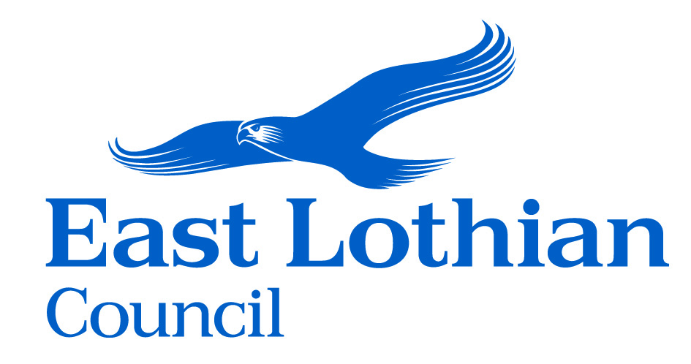
June 2025

USEFUL INFORMATION FOR SUPPLIERS

East Lothian Council is a Local Authority responsible for providing a wide range of services to the residents of East Lothian. The county of East Lothian lies to the South and East of Edinburgh and neighbours Midlothian and the Scottish Borders and has a population of around 112,300. We procure a range of goods, services and works valued at on average over £150m per annum. Sustainability, Climate Change, Fair Work Practices, Community Wealth Building and Community Benefits are very important to East Lothian Council and we are continually looking for ways of achieving social, economic and environmental benefits throughout our procurement activities. We actively encourage suppliers to support the Community Benefits programme when tendering for contracts. Further information about procurement may be found via the East Lothian Council website www.eastlothian.gov.uk/info/210594/procurement or by emailing procurement@eastlothian.gov.uk

Preparing for Tender
Larger procurements can take up to a year to complete depending on contract complexity and whether it is a new contract or a renewal. In preparation for tendering, suppliers must consider what documentation and evidence may be asked for as part of the tender submission and ensure it is available when required, eg., financial statements, insurance certificates, references, evidence of professional accreditations, quality assurance, health and safety policies, data protection policies, IT Security standards, risk management procedures and sustainability practices.

Tender Limits and Tender Quotation Process
Low Value Tenders:
Below £15k
- Up to three written quotes will be requested by the buyer.

Goods and Services above £15k and below £50k, and Works below £500k
- Public Contracts Scotland (PCS) Quick Quote process is used via the PCS portal www.publiccontractsscotland.gov.uk A minimum of three quotations are sought by invitation. You must be registered on PCS and select YES to Supplier Finder to be visible to buyers allowing them to invite your company to quote/tender.

High Value Tenders: Goods and Services above £50k, and Works above £500k
- Tender opportunities are advertised through the PCS portal: www.publiccontractsscotland.gov.uk
Further information is provided on our Business Opportunities webpage: www.eastlothian.gov.uk/info/262/council_procurement/983/business_opportunities

To receive alerts from the Public Contracts Scotland (PCS) portal about newly advertised contracts you must create an Alert Profile, details of how to do this can be found here: www.publiccontractsscotland.gov.uk/helpandresources/userguides

PCS and PCS-Tender (PCS-T) are the two Scottish Government e-Tendering/procurement portals. They are a secure and efficient means for buyers and suppliers to manage the tender/procurement process online. Once suppliers have registered, they are then able to express interest in any advertised open tender exercise. East Lothian Council may utilise either PCS or PCS-T for tenders over £50k.

Tender Evaluation:

The council is looking for the Most Economically Advantageous Tender (ie., best balance of quality and price). Tenderers and their tender submissions will be evaluated on a variety of factors, including but not limited to:
- Service, product or proposal quality | - Technical merit | - Adherence to council policies
- Financial viability | - After sales service | - Appropriate certification, licences
- Competence and capability | - Customer care | - Sustainability
- Experience  - Use of Project Bank Accounts  - Development of local supply chains | - Capacity, availability  - Equality  - Fair Work First | - Innovation  - Prompt Payment within supply chains  - Reporting
- Corporate social responsibility (social, economic and environmental factors)*

*Further advice on evaluation criteria can be found at the Scottish Government website:
https://www.supplierjourney.scot/additional-resources/fair-work-practices-0

Award Notices are published on PCS and this can be a good source of second tier / subcontracting work. Registration is free and alerts can be set up for your sector. Please also note the “advanced search” facility to select regions, etc. The Supplier Development Programme provides advice, training and support about tendering for work via PCS.

Supplier Development
East Lothian Council hold “Meet the Buyer” events throughout the year and are members of the Supplier Development Programme (www.sdpscotland.co.uk). Membership of SDP Scotland and “Meet the Buyer” events are free. If you are a supplier based in East Lothian and have any special requests for specific topics, courses or events please get in touch via the procurement@eastlothian.gov.uk mailbox. We encourage suppliers to review the Supplier Journey website (www.supplierjourney.scot) as this offers guidance and templates for public sector contract tendering. We would also encourage East Lothian suppliers to register for free on the East Lothian Business Directory www.eastlothian.com

Contracts, Frameworks & Forthcoming Work
East Lothian Council contracts may be found via www.eastlothian.gov.uk/info/210594/procurement/11999/business_opportunities

Larger forthcoming contracts are published on PCS and we recommend that suppliers register on PCS so that they receive notifications not only from us but other councils and organisations across Scotland.

We are members of Scotland Excel (www.scotland-excel.org.uk) and regularly award contracts using their frameworks. Additionally, we and other public sector organisations throughout Scotland actively utilise the national frameworks developed by Procurement Scotland (PS) (www.gov.scot/Topics/Government/Procurement/directory).

Forthcoming Scotland Excel (SXL), Scottish Procurement (SP), NHS and APUC contracts/frameworks can be found on PCS: www.publiccontractsscotland.gov.uk/helpandresources/forwardplan

Forthcoming ESPO, NEPO, Crown Commercial Services, YPO, Bloom, Procurement for Housing, Fusion 21, and the Procurement Partnership’s contracts/frameworks can be found on Find a Tender: www.find-tender.service.gov.uk/Search

East Lothian Council and other public sector organisations also utilise Dynamic Purchasing Systems (DPS) of the above organisations. DPS’s are similar to framework agreements, but suppliers can apply to join a DPS at any time, and further competition must always be carried out for all call off contracts.
Examples of existing Categories and Contracts

 | Social Care & Strategy | Construction & Maintenance of buildings & roads | Fleet & Environment incl. Utilities | Corporate & Facilities  Education
Examples of goods and services contracts currently utilised by East Lothian Council. | - Care at Home and Supported Living  - Residential Care  - Foster Care  - Day care provision  - Aids & adaptations  - Technology Enabled Care  - Community Meals  - Private Sector Leasing  - Supported Accommodation | - Construction Projects  - Roads Projects  - Property Maintenance materials (e.g. timber, doors, kitchens, plumbing, electrical & paint)  - Roads materials (e.g. bitumen, black top & aggregates)  - Salt  - Tools & Plant & Equipment  - PPE  - Landscape & countryside plant & services  - Construction Consultancy  - Security  - Asbestos related works  - Signage  - Street Lighting | - Light vehicles  - Heavy vehicles  - Home to school transport  - Taxis  - Public bus routes  - Coach hire  - Tyres  - Vehicle spare parts  - Hire of vehicles & equipment  - Waste disposal equipment  - Waste disposal services  - Waste containers  - Sacks & liners  - Utilities – electricity, gas & water | - Consultancy  - IT Hardware  - Software  - Stationery & IT consumables  - Printing  - Audio- visual  - White goods  - Postage & Couriers  - Food (groceries, frozen food, fresh butcher meat, fruit & veg, bread, eggs & milk)  - Catering disposables & sundries  - Agency Staff  - Educational supplies  - Furnishings & Furniture  - Events  - Banking & Insurance Services

Community Benefits in Procurement
In delivering services to East Lothian, East Lothian Council is committed to developing wider benefits to its citizens, through engagement with suppliers, providers and contractors, in providing links with schools, work experience opportunities, training opportunities, apprenticeships, assistance with community projects, as well as support towards delivering the carbon emissions reduction and sustainability outcomes set out in East Lothian Council’s Climate Change Strategy 2025 - 2030 (www.eastlothian.gov.uk/downloads/file/34732/climate_change_strategy_2025-2030). It is about achieving additional benefit for the community and as such East Lothian Council wishes to achieve wider value from public spending, specifically to and for the benefit of the community.

Community Benefits which may be proposed within tender submission could include:
• Training and Work Experience (East Lothian Resident)
• Employability & Skills
• Education and Outreach
• Local Economy and Social Enterprises
• Community Engagement Projects
• Protecting and Improving our Environment

To allow us to achieve maximum Community Benefits we will look for delivery of Community Benefits on contracts over £50K, or for smaller contracts, once the aggregated spend has reached £50K. Delivery of that benefit will be monitored as part of the contract monitoring process.

We appreciate that businesses new to this approach may feel daunted, but please be assured that East Lothian Council’s Corporate Procurement Team in conjunction with the Community Benefits Officer will support and guide you through the process including actual delivery of the benefits themselves.

Sustainable Procurement
East Lothian Council is committed to maximising the social and economic benefit derived from its procurements and in minimising the environmental impact of goods, services and works that it procures. The council has declared a Climate Emergency that requires urgent action to make all Council Services net Zero Carbon as soon as possible and in any case by 2045 and to lobby, support and work with all relevant agencies, partners and communities to fulfil this commitment. East Lothian Council has also committed to work with its communities and partners towards making East Lothian a carbon neutral county. Sustainability is embedded within the council’s Climate Change Strategy 2025 – 2030 (www.eastlothian.gov.uk/downloads/file/34732/climate_change_strategy_2025-2030) with the commitment to continue to reduce the environmental impact of East Lothian Council Service Provision.

East Lothian Council is expected to ask bidders and suppliers to provide low carbon goods, services and work, and deliver circular solutions as part of the tender and contract management process.

East Lothian Council will consider including climate selection criteria in the procurement exercise that will result in carbon reduction. This could be done by including KPI(s) as part of the contract delivery requirements and also the inclusion of climate selection criteria into the (SPD). The selection criteria will be proportionate and considered for all relevant contracts or priority contracts. To find out more about relevant and priority contracts please visit the Supplier Journey Website (https://www.supplierjourney.scot/additional-resources/climate-emergency/what-do-i-need-do-climate), which contains examples of the Climate Change Plan Templates.

Further information about procurement can be found via the East Lothian Council website https://www.eastlothian.gov.uk/procurement or by emailing procurement@eastlothian.gov.uk

Supplier Questionnaire 2025/6
East Lothian Council would be grateful if you can complete our Supplier Questionnaire available via the below QR code or online https://eastlothianconsultations.co.uk/council-resources/supplier-questionnaire-2025-2026



