Meet the Buyer 2023

[www.sdpscotland.co.uk](https://www.sdpscotland.co.uk/events/inverclyde-council-meet-the-buyer-1438/)

17 May 2023

Updated: 19/10/2023

Lynzie McLean, SDP Marketing and Events Assistant

[lynzie.mclean@southlanarkshire.gov.uk](mailto:lynzie.mclean@southlanarkshire.gov.uk)

Draft 1.4

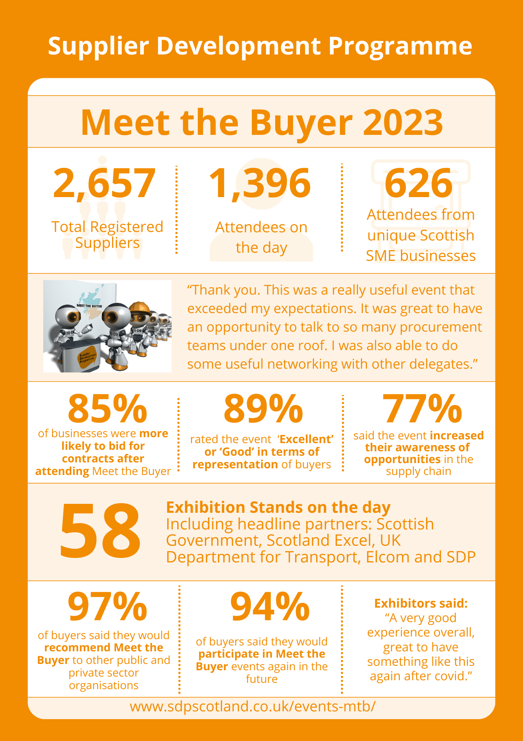

**Overview**

The Supplier Development Programme has published an online report on the Meet the

Buyer 2023 event which took place on 17 May 2023 at the Edinburgh International Conference Centre. The Scottish Government, Scotland Excel, UK Department for Transport and Elcom were official partners of this event. In addition, OutSystems were the premium partner.

Meet the Buyer 2023 marks the first in-person national Meet the Buyer event since the outbreak of the COVID-19 pandemic in 2020.This free event affords suppliers unprecedented access to buyers and decision makers from across the Public and Private sector, with the opportunity to raise their profile as a business and prepare for upcoming contract opportunities.

Meet the Buyer 2023 also marks the first partnership between the Supplier Development Programme and the UK Department for Transport, with the addition of the Department for Transport Zone, an area dedicated to Transport organisations and other national public bodies from across the United Kingdom.

**Supplier Registration and Attendance**

In total, 2,657 suppliers had pre-registered interest on the SDP website for the Meet the Buyer 2023. There were 1,396 actual attendees on the day. Of those, 862 attendees from 626 Scottish SME unique businesses attended Meet the Buyer 2023.

**Buyer Exhibitions**

Meet the Buyer 2023 exhibitors included the headline partner organisations: The Scottish Government, Scotland Excel, UK Department for Transport, Elcom, and the Supplier Development Programme. In addition, OutSystems exhibited at Meet the Buyer as a Premium Partner.

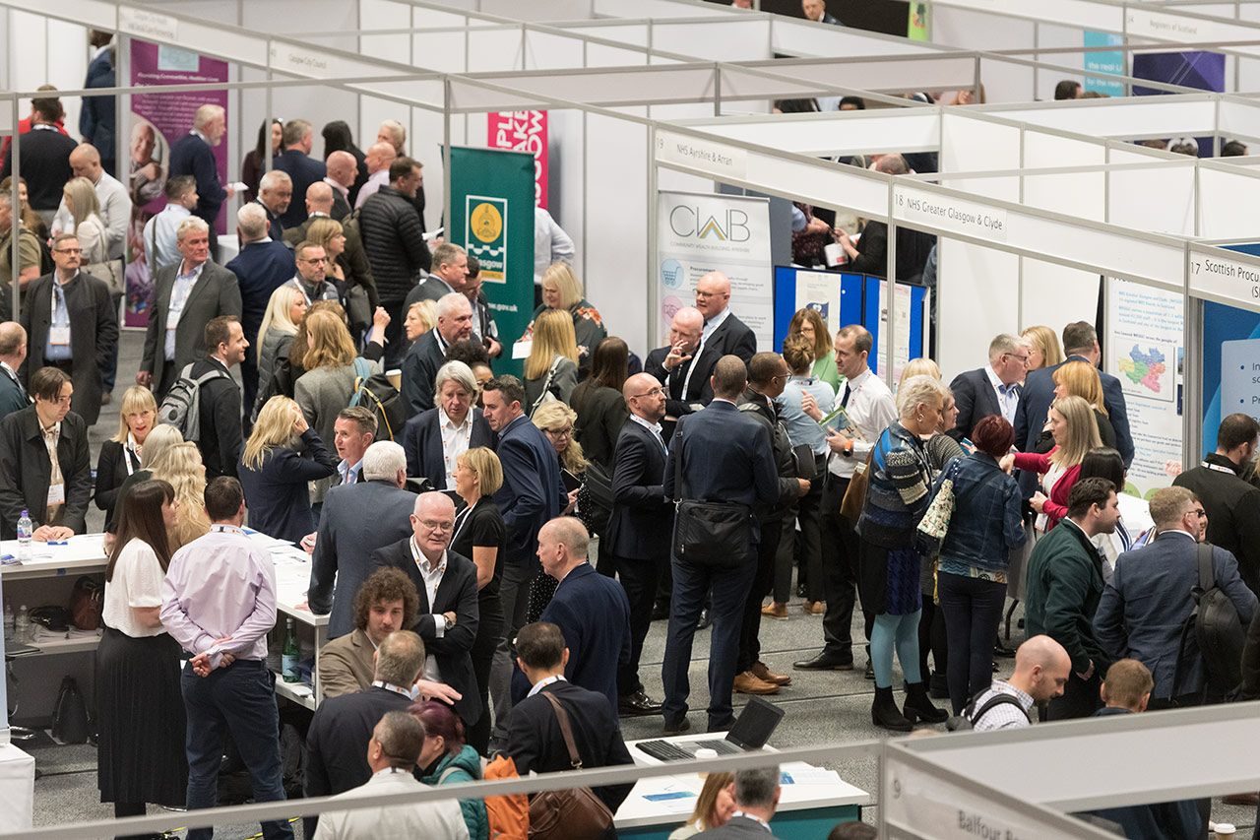In total, there were 58 exhibitions which included a range of public sector buyers, business support organisations and some supply chain contractors, including Balfour Beatty, Robertson Facilities Management, Ogilvie Construction, McAleer & Rushe, RJ McLeod, and hub East Central Scotland Limited.

**Formal Agenda**

There were 2 stages at Meet the Buyer 2023: The Power of Procurement Stage and The UK Department for Transport Stage.

Peter Henderson, Chair of the Supplier Development Programme delivered a Welcome Address to open the Power of Procurement Stage. Tom Arthur MSP, Minister for Community Wealth and Public Finance, delivered a Ministerial Address and participated in a Question-and-Answer session.

Other presentations on the Power of Procurement Stage include:

* Stephen Brannagan, Director of Customer & Business Services for Scotland Excel, delivered a presentation titled ‘Scotland Excel: Public Procurement, a New Beginning’.
* Wendy Rayner, Head of NHS Circular Economy Programme: Directorate for Health Finance, Corporate Governance & Value, provided an introduction to the NHS Circular Economy Programme.
* Chris Sanderson MCIPS, Head of Procurement, NHS Greater Glasgow & Clyde, discussed ‘How to Do Business with NHS Greater Glasgow & Clyde’.
* Jamie Robinson, Hydrogen Specialist, Scottish Enterprise Low Carbon Transition Team, discussed Scottish Hydrogen Supply Chain Opportunities.
* A person standing at a podium in front of a crowd of people

  Description automatically generatedHeather O’Donnell, Technical Support Manager, Scottish Procurement Alliance, highlighted Upcoming Public Sector Framework Opportunities.

**Formal Agenda: Department for Transport Stage**

The Supplier Development Programme and UK Department for Transport created a short agenda of presentations for the Department for Transport Stage. A shorter formal programme would therefore allow ample time for suppliers to talk 1:1 with buyers, allowing exhibitors and attendees to focus on face-to-face, in-person networking.

Presentations on the Department for Transport Stage included:

* The Welcome Address was delivered by Mark Phillips, Head of Commercial Lifecycle Assurance, Assurance and Supply Chain Management, Group Commercial Directorate, Department for Transport.
* Paul Rodgers, Commercial Director at the UK Department for Transport, delivered a Keynote Address.
* Martin Traynor OBE, Cabinet office SME Crown Representative, delivered a Keynote Address.
* Ian Edwards, Head of Commercial Strategy, Strategy, Policy and Capability, Group Commercial Directorate, UK Department for Transport, provided an update on Commercial Policy.
* 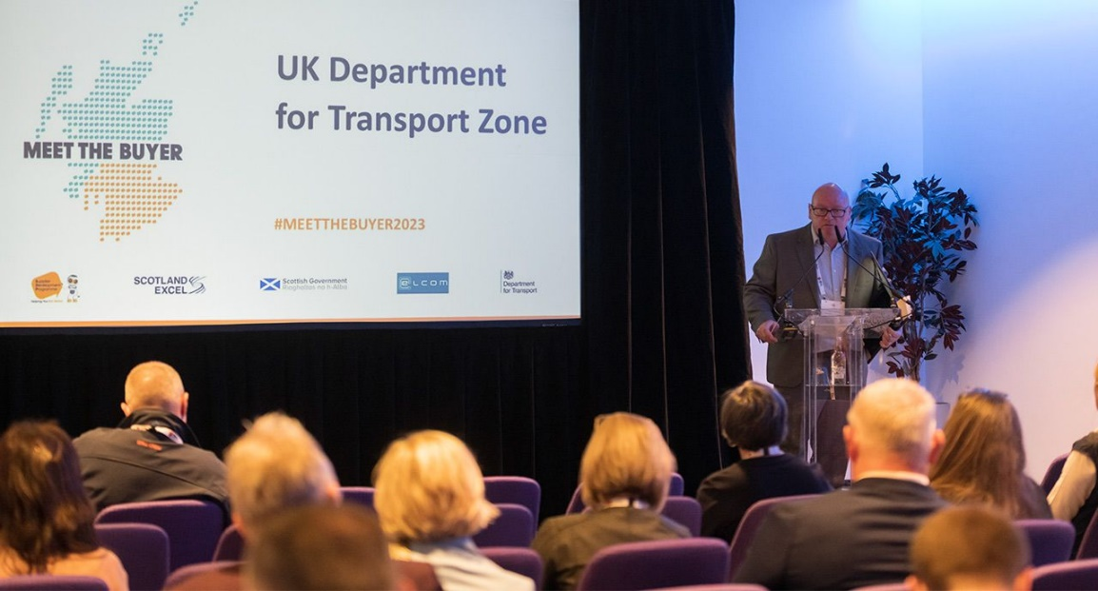Clara Matty, SME Relationship Manger for AECOM, delivered a presentation titled “How to Win Work in the Supply Chain”.

**Scotland Excel and Supplier Development Programme- supporting potential suppliers bid for their frameworks.**

To drive a visible, joined-up approach to promote Scotland Excel's framework opportunities and the Supplier Development Programme's tender training and support for Scotland's businesses, both organisations signed a Memorandum Of Understanding (MOU), at the event, witnessed by Tom Arthur MSP, Minister for Community Wealth and Public Finance, Scottish Government.

**Supplier Survey Feedback**

An online survey was distributed to all registered suppliers for the Meet the Buyer event. The survey was live between 12 May 2023 to 16 June 2023. Within this time, 140 responses were received. 106 of these responses came from SMEs, Social Enterprises, and third sector organisations.

**The post-event survey highlighted that 85% of Scottish SMEs said they were more likely to bid for public contracts after participating in the event**.

The survey also highlighted that:

* 89% of suppliers rated the Meet the Buyer 2023 event as ‘excellent’ or ‘good’ in terms of representation of public sector buyers and decision makers.
* 77% of respondents said that this event had increased their awareness of opportunities for their businesses in the supply chain.
* 70% of suppliers felt more confident about bidding for public sector contracts after attending Meet the Buyer 2023.
* 62% of suppliers believe they made contacts at Meet the Buyer 2023 which may have the potential to benefit their business in the next year, either through bidding for future contracts or being invited to Quick Quote.

Suppliers that responded to the survey also rated the Meet the Buyer 2023 event as ‘absolutely essential’ or ‘very important’ in several areas:

* 78% feel Meet the Buyer is important in helping SMEs, charities and third sector organisations learn more about upcoming contracts and understand the tendering process.
* 83% feel these events are important for connecting public sector buyers and decision makers with charities, and third sector organisations.
* 65% feel Meet the Buyer is important for putting into practice the National Performance Framework – part of which is encouraging better procurement practices.

When considering the Scottish Government’s commitment to becoming a Net Zero society

by 2045:

* 87% of respondents were aware of the Scottish Government’s commitment to achieving a Net Zero society.
* 68% of respondents said they have an existing policy to support a reduction in its carbon footprint, and 69% said they have an implementation plan to reduce its carbon footprint.
* 43% said that carbon reducing/reaching net zero targets is a priority right now in 2023 for its business.
* 41% said it is a priority in future business plans.
* 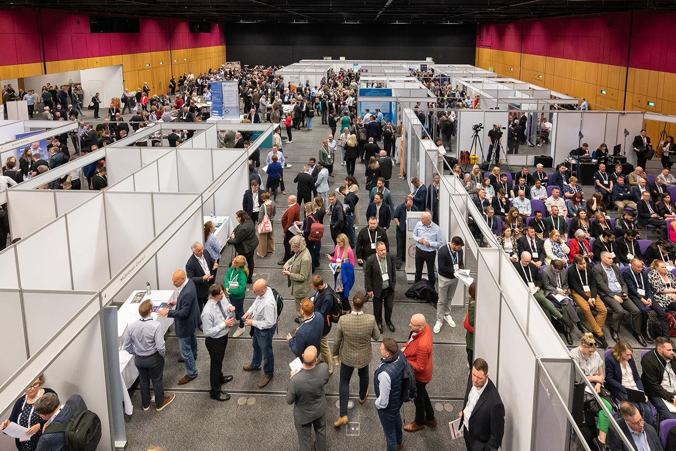16% said Net Zero is not a business priority.

Some comments from suppliers included:

* “Thank you. This was a really useful event that exceeded my expectations. It was great to have an opportunity to talk to so many procurement teams under one roof. I was also able to do some useful networking with other delegates.”
* “Really useful event - my only complaint is having the sessions open plan - the noise from the exhibitors impacted on being able to listen to the speakers. That being said, it was a really good event.”
* “Thank you to all concerned; good venue very well run.”
* “Really enjoyed the event and it was useful to speak to many of the people on the stands. I think this is a real opportunity to have more participative sessions on procurement best practice and procurement barriers. I would have really liked to see an overall insights session on public procurement- some key stats around volume of opportunities through the main portals, categories of opportunities per buyer, numbers, or values of contracts. You should have clear delegate badges for- buyer, supplier, both. You should do a more general- what's new in procurement session- sharing the key trends with non-procurement delegates. You could focus seminars on topics such as Climate Action, Community Impact etc. These sections are increasingly moving from non-scoring to scoring requirements.”
* “Venue was far from adequate for the event, waited 45 mins to get registered. Parking was also a nightmare.”
* “Please identify Buyers differently from suppliers. It was difficult to tell who people were when trying to get to speak with a Buyer form an organisation - especially when they were just chatting amongst themselves.”
* “Practical information, such as the Wi-Fi password for the venue, would be useful for future events, along with greater use of digital technology to capture information from those present- too much paper and not enough QR codes etc- appreciate cannot be forced, but could be encouraged, plus is a more practical way of following up.”
* “I found the delays on entering were extremely disappointing. I queued for well over an hour just to get my badge and lanyard, where had we printed out badges, scanned a QR code on entry then picked up a lanyard entry would have been seamless, but I appreciate the situation.”
* “I missed the speaking segments that would have supported my organisation with bid writing due to the length of the queues at registration.”

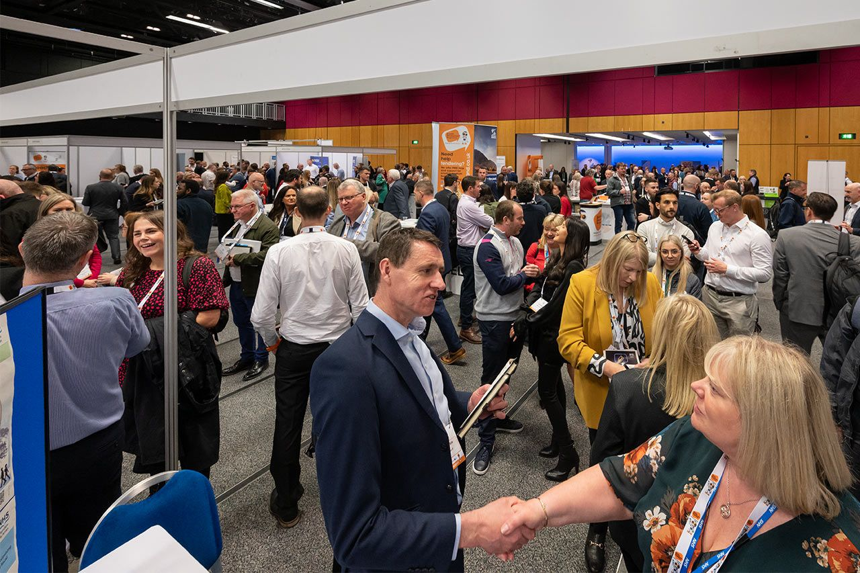

**Supplier Survey Feedback: Department for Transport Zone**

**The post-event survey highlighted that 47% of respondents visited the UK Department for Transport Zone at Meet the Buyer 2023.**

The post-event survey highlighted that:

* 23% of respondents currently work with organisations present in the Department for Transport Zone.
* 58% of respondents do not currently work with organisations present in the Department for Transport Zone.
* 19% of respondents did not know if their business currently works with any of the organisations present in the Department for Transport Zone.

When considering the organisations in the Department for Transport Zone and their supply chains:

* 10% of respondents plan to pursue opportunities with the Foreign, Commonwealth & Development Office.
* 18% of respondents plan to pursue opportunities with Amey Scotland.
* 11% of respondents plan to pursue opportunities with the Department for Transport exhibitors.
* 4% of respondents plan to pursue opportunities with Department for Transport Zone
* 71% of respondents do not plan to pursue opportunities with any of the organisations present in the Department for Transport Zone.

When rating the event in relation to the overall Department for Transport Zone experience:

* 17% of respondents were very satisfied with the event.
* 33% of respondents were satisfied with the event.
* 24% of respondents were neither satisfied nor dissatisfied with the event.
* 1% of respondents were dissatisfied with the event.
* 3% of respondents were dissatisfied with the event.

Some comments from suppliers regarding the DFT Zone included:

* “Some key stakeholders in procurement made the effort to attend this event and engage with suppliers. I was very impressed with their enthusiasm to engage with SME buyers.”
* “None. Great networking event.”
* “Wonderful, well-organised with interesting speakers and content.”
* “Very low key - a lot of people openly said they were not sure if it added benefit to them.”
* 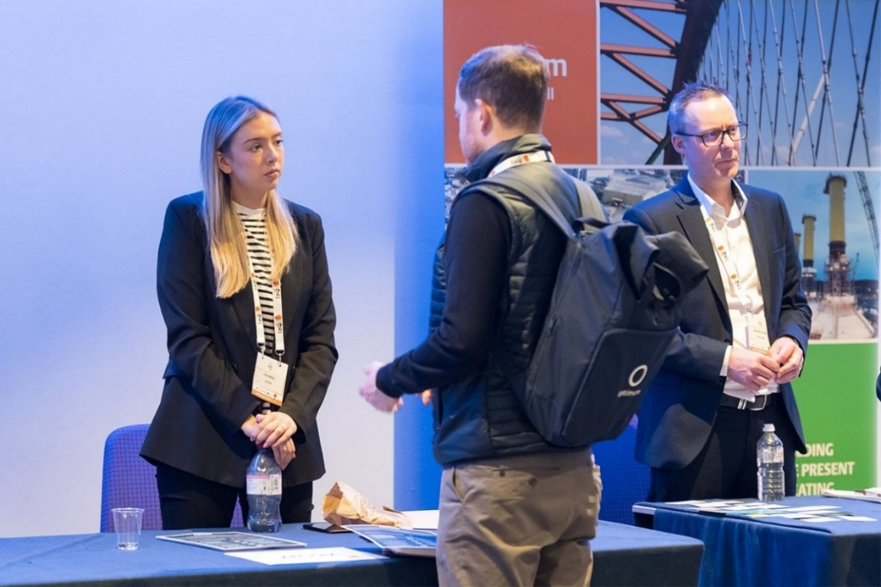“It was unprofessional of the larger buyers like Network Rail not to take a proper stand like ScotRail did. It would have been better to have all of the supply chains have those larger desk things in the middle, that was good actually.”

In terms of the barriers to greater SME participation with DfT Group and its supply chain, suppliers highlighted the following issues:

* “More engagement like these events.”
* “Knowledge, if I did not attend this event, I would be ignorant to SME participation in DfT groups.”
* “Information accessibility.”
* “Knowing DfT strategies are for the coming years to tailor business to align.”
* “Pipeline visibility.”
* “Knowing who to contact.”
* “Communication and connections.”
* “Knowledge of contract opportunities. More publicity required.”
* “Lack of visibility of opportunities, large companies squeezing SMEs out due to pricing, and if we are in their supply chain already - squeezing us on price and preferring their own resources over subcontractors.”
* “It is not set up to help SMEs all geared to Tier 1 companies.”
* “Possibly a misconception but I think the nature of the contracts tends to be more suitable for larger companies.”
* “Opportunities that are let in a way which do not require us to subcontract to a large company. This puts considerable pressure on our day rates and often results in us having to fight for a fair workshare.”
* “Size of department - easier to work with private companies such as LNER/Scotrail etc.”
* “They simply don't understand how to connect with Scottish businesses like mine. I don't think the UK is very interested in Scottish suppliers as there are so many English companies kicking about down South. They should probably engage with SDP more.”

**The post-event survey highlighted that 78% of respondents would like to see further Department led industry engagement events of this nature.**

**Exhibitor Feedback Survey**

An online survey was distributed to registered exhibitors after the Meet the Buyer 2023

event. This survey was live from 12 May 2023 to 16 June 2023. Within this time, 34 responses were received.

The post event survey highlighted:

* 94% of buyers said they would participate in Meet the Buyer events in the future.
* 97% of buyers said they would recommend Meet the Buyer to other public sector buyers, private contractors with supply chains, and business support organisations.

Exhibitor respondents agreed the in-person event helped to:

* 82% - Drive early engagement to help meet the Sustainable Procurement Duty SDP member organisations, through collaboration with procurement and economic development to increase the number and breadth of public sector contracts being accessible to the Scottish SME base.
* 85% - Raise the profile of SDP to be recognised and established as the primary tender training programme to support SMEs and third sector in Scotland.
* 91% - Extend SDP engagement with public sector buyers to ensure SMEs benefit from local contracts.
* 85% - Demonstrate that public sector procurement is open and transparent, despite the challenges caused by the COVID-19 pandemic.
* 71% - Engage with suppliers on Community Wealth Building opportunities and aspirations.

Some comments from buyers included:

* “It was a busy and enjoyable event.”
* “Overall good event with a good number of suppliers attending.”
* “A very good experience overall, great to have something like this again after covid.”
* “It was an excellent experience; we spoke to so many people and made a lot of great connections.”
* “It was good to meet so many people but was almost too busy at times!”
* “Although the event is useful for meeting suppliers, we are still constrained by suppliers choosing to interact at tender stage.”
* “The event itself is a great opportunity to meet suppliers who really need the guidance on public procurement I just feel that many suppliers and buyer's get overwhelmed by how busy and nonstop the event is. Suppliers at the stands become very conscious of the large queue behind them and often cut conversations sort.”
* “We split attendance on our stand but there was no lunch for 2 of us (mind you it was around 2pm when we got a break). Event duration was better but maybe make the event from 10-3 for travelling purposes.”
* “The event was excellent overall and an excellent opportunity to engage with SMEs which is what we wanted to do. Our stand was exceptionally busy (as we knew it would be) being an Edinburgh event. I think next time it would be really appreciated if we could be put on an end so we could manage queues better. We felt bad for the other stalls as our queue was frequently blocking theirs, but we couldn't do anything about it given our location even though we had plenty of colleagues to help.”

**All feedback from suppliers and buyers is valuable and will be applied to future events organised by the Supplier Development Programme.**

**Promotion through the Supplier Development Programme**

**Social Media Analytics**

The Supplier Development Programme has a robust social media presence on Twitter, Facebook, and LinkedIn, which is utilised to promote contract opportunities and engagement events regularly to Scottish businesses. In advance of the Meet the Buyer 2023 event, SDP promoted the event across its social media channels. The campaign ran from 19 December 2022 to 17 May 2023 and collectively the posts earned 33,758 impressions (the number of times users saw a post) and 1,566 engagements (the total times a user interacted with a post).

**Newsletters/Mailings**

The Meet the Buyer event was announced in SDP’s December 2022 monthly newsletter, and featured in all subsequent Newsletters before the event, on 17 May.

* January 2023 Newsletter received 216 clicks.
* February 2023 Newsletter received 276 clicks.
* March 2023 Newsletter received 207 clicks.
* April 2023 Newsletter received 190 clicks.
* May 2023 Newsletter received 294 clicks.

The week before the event, on 10 May, SDP sent out a “one week to go” reminder mailing to all registered suppliers recapping all the information the suppliers would need to attend the event. The Meet the Buyer event page received 27 clicks and the supplier event guide page received 895 clicks.

The day before the event, on 16 May, SDP sent out a “one day to go” reminder mailing to all registered suppliers. The Meet the Buyer event page received 38 clicks and the supplier event guide page received 1262 clicks.

**Meet the Buyer 2023 Collateral**

The presentation sessions from the Power of Procurement Stage at Meet the Buyer 2023 are available on the [SDP [YouTube](https://www.youtube.com/channel/UCIqFOcumpnKlu1wQOrIkQvQ) channel](https://www.youtube.com/channel/UCIqFOcumpnKlu1wQOrIkQvQ), allowing those who could not attend on the day access to watch the full range of speaker presentations and the tendering workshop delivered by the Supplier Development Programme.

**Post Event**

Both delegate and exhibitor feedback has been reviewed and individual questions addressed. SDP has had discussions with its event contractor, addressing the issues raised with regard to queues and other points so that we continue to provide a high-quality service to both the public and private sectors.

The Department of Transport and other UK departments are keen to participate in 2024, which will see the event return to Glasgow.

**Contact**

More information on the Supplier Development Programme can be found at [www.sdpscotland.co.uk](http://www.sdpscotland.co.uk) and on social media via [Twitter](https://twitter.com/sdpscotland), [Facebook](https://www.facebook.com/SupplierDevelopmentProgrammeScotland), [LinkedIn](https://www.linkedin.com/company/sdpscotland/), and [YouTube](https://www.youtube.com/channel/UCIqFOcumpnKlu1wQOrIkQvQ).