Meet the Buyer Ayrshire 2023

[www.sdpscotland.co.uk](https://www.sdpscotland.co.uk/events/inverclyde-council-meet-the-buyer-1438/)

4 October 2023

Updated: 04/12/2023

Julie Shennan, SDP Marketing and Events Development Officer

[julie.shennan@southlanarkshire.gov.uk](mailto:julie.shennan@southlanarkshire.gov.uk)

**Overview**

The Supplier Development Programme has published an online report on the Meet the

Buyer Ayrshire 2023 event, which took place on 4 October 2023 at The Park Hotel - Kilmarnock. Alongside the Supplier Development Programme, the Scottish Government, East Ayrshire Council, North Ayrshire Council and South Ayrshire Council were partners.

This free to attend event gave suppliers in the Ayrshire region unprecedented access to buyers and decision makers from across the Public and Private sector. It enabled them to raise their profile as a business and prepare for upcoming contract opportunities.

**Supplier Registration and Attendance**

In total, 167 suppliers pre-registered interest on the SDP website for Meet the Buyer Ayrshire 2023. There were 96 actual attendees on the day. Those attendees represented 69 Scottish SME unique businesses.

**Buyer Exhibitions**

Supplier Development Programme, Scottish Government, East Ayrshire Council, North Ayrshire Council and South Ayrshire Council were partners.

In total there were 13 exhibition stands, which included a range of public sector buyers, business support organisations, and a number of supply chain contractors, including: Scottish Procurement Alliance (SPA), Scottish Fire and Rescue, NHS Ayrshire and Arran, Scottish Enterprise, Scotland Excel, Living Wage Scotland, Hub South West and Ayrshire Growth Deal.

**Formal Agenda**

The day opened with an informal welcome note, before networking commenced.

Presentations on the day included:

* 2:45pm - Supplier Development Programme: Top Tips for Tendering, led by SDP Programme Manager Gillian Cameron.
* 3:30pm - Ayrshire Growth Deal, Community Wealth Building, led by Programme Manager Jude King.

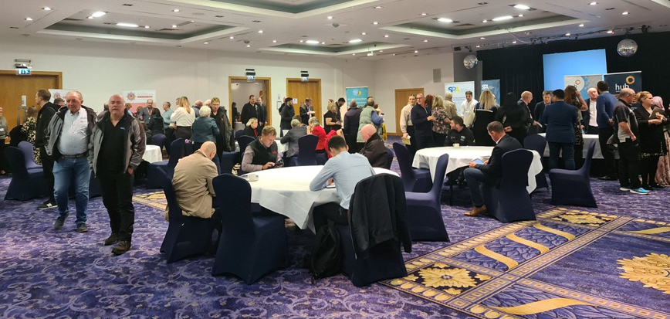

**Supplier Survey Feedback**

An online survey was distributed to all that attended Meet the Buyer Ayrshire 2023. The survey was live from 6 October to 30 November 2023 and 16 responses were received. Of these responses 11 came from SMEs, Social Enterprises, and third sector organisations.

**The post-event survey highlighted that 100% of Scottish SMEs said they were more likely to bid for public contracts after participating in the event**.

**The survey also highlighted that:**

* 80% of suppliers rated the event as ‘excellent’ or ‘good’.
* 93% of respondents said that this event had increased their awareness of opportunities for their businesses in the supply chain.
* 100% of suppliers felt more confident about bidding for public sector contracts after attending Meet the Buyer Ayrshire 2023.
* 92% of suppliers said they think they would not have engaged with these supply chain opportunities without this event.
* 86% feel Meet the Buyer Ayrshire was important in helping SMEs, charities and third sector organisations learn more about upcoming contracts and understand the tendering process.

**When considering the Scottish Government’s commitment to becoming a Net Zero society by 2045:**

* 80% of respondents were aware of the Scottish Government’s commitment to achieving a Net Zero society.
* 66% of respondents said they have an existing policy to support a reduction in their businesses’ carbon footprint.

**Some comments from suppliers included:**

“I enjoyed speaking directly to key people, it’s something that you do not often get a chance to do. We received very good advice and some more understanding of the supplier process.”

“[It was] very helpful and informative, I now have more awareness of required information relevant to specific need.”

“We had a good experience. We have attended a few of these events and it has taken us a while to gain the knowledge to know what questions to ask.”

“These events are very helpful for SMEs.”

“It was really informative.”

“All very professional.”

**All feedback from suppliers and buyers is valuable and will be applied to future events organised by the Supplier Development Programme.**

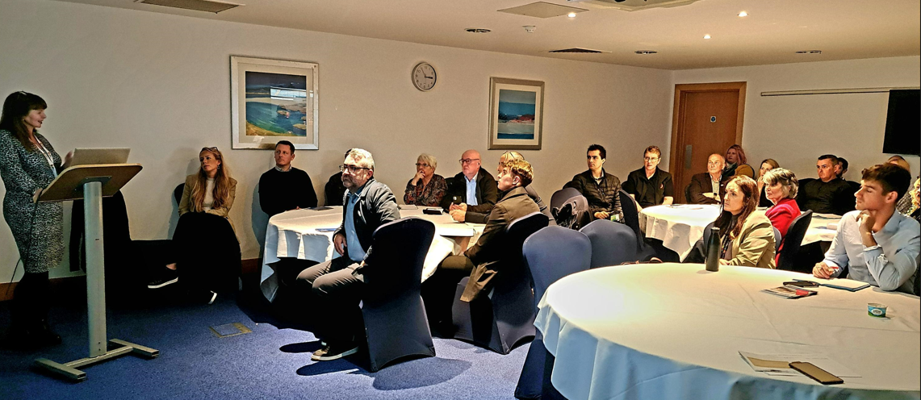

**Promotion through the Supplier Development Programme**

**Social Media Analytics**

Prior to the event, SDP published 10 posts, across each of these platforms: Facebook, LinkedIn and Twitter, promoting Meet the Buyer Ayrshire.

The campaign ran from 14 September to 4 October. Collectively, the posts earned 4,917 impressions (the number of times users saw a post) and 425 engagements (the number of times users interacted with posts). In total, there were 262 clicks on the links embedded in these posts.

**Highest performing posts include:**

**Newsletters/Mailings**

The Meet the Buyer Ayrshire event was announced in SDP’s September 2023 monthly newsletter, and featured in all subsequent Newsletters before the event, on 4 October.

* 4 August: September Newsletter, received 85 clicks.
* 21 September: Discover Public Sector Opportunities in Ayrshire mailing, received 61 clicks.
* 29 September: Still Time to get your Free Tickets for Meet the Buyer Ayrshire mailing, received 64 clicks.

**Post Event**

Both delegate and exhibitor feedback has been reviewed and individual questions addressed. SDP has had discussions with its event contractor, addressing the issues raised with regard to queues and other points so that we continue to provide a high-quality service to both the public and private sectors.

**Contact**

More information on the Supplier Development Programme can be found at [www.sdpscotland.co.uk](http://www.sdpscotland.co.uk) and on social media via [Twitter](https://twitter.com/sdpscotland), [Facebook](https://www.facebook.com/SupplierDevelopmentProgrammeScotland), [LinkedIn](https://www.linkedin.com/company/sdpscotland/), and [YouTube](https://www.youtube.com/channel/UCIqFOcumpnKlu1wQOrIkQvQ).