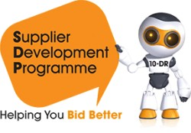

Meet the Buyer Tayside
www.sdpscotland.co.uk
21 March 2023

Updated: 19/06/2023
Lynzie McLean, SDP Marketing and Events Assistant
lynzie.mclean@southlanarkshire.gov.uk

Draft 1.0
Overview
This report covers the activities and outcomes from the Meet the Buyer Tayside event, which took place on 21 March 2023 at the Invercarse Hotel, Dundee.

The drop-in event was arranged in partnership between Dundee City Council, Perth & Kinross Council, Angus Council and the Supplier Development Programme to give prospective suppliers the chance to find out more about upcoming contracts, procurement processes, and what an organisation looks for when buying goods and services.

Supplier Registration and Attendance
In total, 445 suppliers pre-registered interest on the SDP website for the Meet the Buyer Tayside event. There were 268 actual attendees on the day. Of those, 185 attendees were from 144 unique Scottish SME businesses. Of those, 44 unique Scottish SMEs were based in Dundee, 20 in Perth & Kinross and 14 in Angus.
Buyer Exhibitions
Businesses of all sizes had the opportunity to meet Buyers from most of the Public Sector organisations in and around Tayside, including Angus Council, Dundee City Council, Fife Council, Perth & Kinross Council, NHS Tayside, Universities, Colleges, Tayside Contracts and more.
.

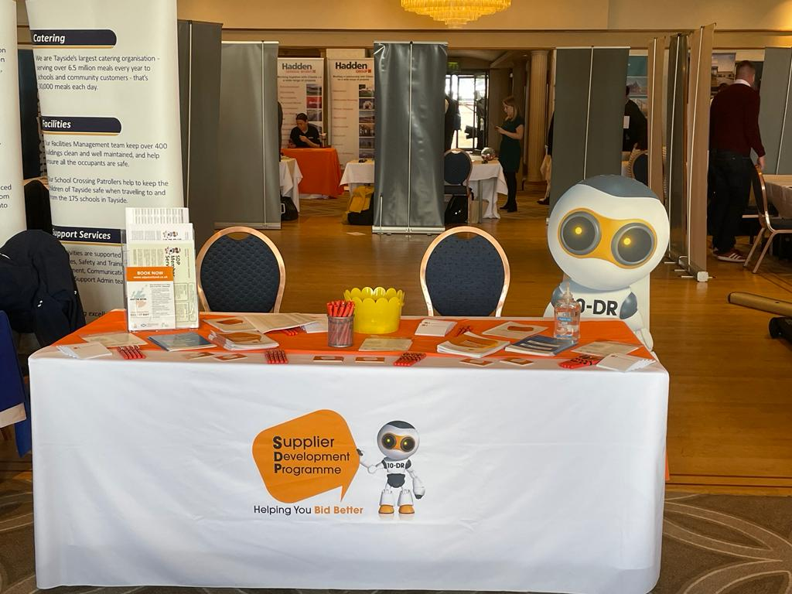

Supplier Survey Feedback
An online survey was distributed to all registered suppliers for the Tayside Meet the Buyer event. The survey was live between 8 March 2023 to 21 April 2023. Within this time, 14 responses were received.

The post-event survey highlighted that 71% of Scottish SMEs were more likely to bid for public sector contracts after participating in the Meet the Buyer Tayside event.

Scottish SME suppliers that responded to the survey also rated the Meet the Buyer Tayside event as ‘excellent’ or ‘good’ in several areas:
- 79% - representation of public sector buyers and decision makers.
- 86% - rated the overall experience excellent or good.
- 64% of respondents thought the Tayside Meet the Buyer event demonstrated that public sector procurement is open and transparent.

When considering the Scottish Government’s commitment to becoming a Net Zero society by 2045:
- 93% of respondents were aware of the Scottish Government’s commitment to achieving a Net Zero society.
- 79% of respondents said they have an existing policy to support a reduction in its carbon footprint, and 71% said they have an implementation plan to reduce its carbon footprint.
- 57% said that carbon reducing/reaching Net Zero targets is a priority right now in 2022 for its business.
- 29% said Net Zero is a priority in future business plans, while 14% said Net Zero is not a business priority.

Regarding support received from the Supplier Development Programme through participation in previous SDP training/or events, Scottish SMEs thought:
- 79% of respondents had participated in SDP training and/or events.
- 73% said that SDP training/or events helped their business to build confidence around tendering.
- 73% said that SDP training/or events helped their business to improve tendering skills.

Some comments from suppliers included:
- “The presence of private sector companies provided additional opportunities for us.”
- “Good event for small businesses trying to advertise their services.”

Promotion through the Supplier Development Programme

Social Media Analytics
The Supplier Development Programme has a robust social media presence on Twitter, Facebook, and LinkedIn, which is utilised to promote contract opportunities and engagement events regularly to Scottish businesses. In advance of the Meet the Buyer Tayside event, SDP promoted the event across its social media channels.
The campaign ran from 16 February to 13 March and collectively the posts earned 4,113 impressions (the number of times users saw a post) and 100 engagements (the total times a user interacted with a post).

Newsletters/Mailings
The Meet the Buyer Tayside event was announced in SDP’s January monthly newsletter which received 232 clicks. The event was also featured in SDP’s February and March newsletter, which received 172 clicks and respectively 132 clicks.

Contact
More information on the Supplier Development Programme can be found at www.sdpscotland.co.uk and on social media via Twitter, Facebook, LinkedIn, and YouTube.

