Meet the Buyer North 2023

[www.sdpscotland.co.uk](https://www.sdpscotland.co.uk/events/inverclyde-council-meet-the-buyer-1438/)

12 September 2023

Updated: 29/11/2023

Lynzie McLean, SDP Marketing and Events Assistant

[lynzie.mclean@southlanarkshire.gov.uk](mailto:lynzie.mclean@southlanarkshire.gov.uk)

Draft 0.4

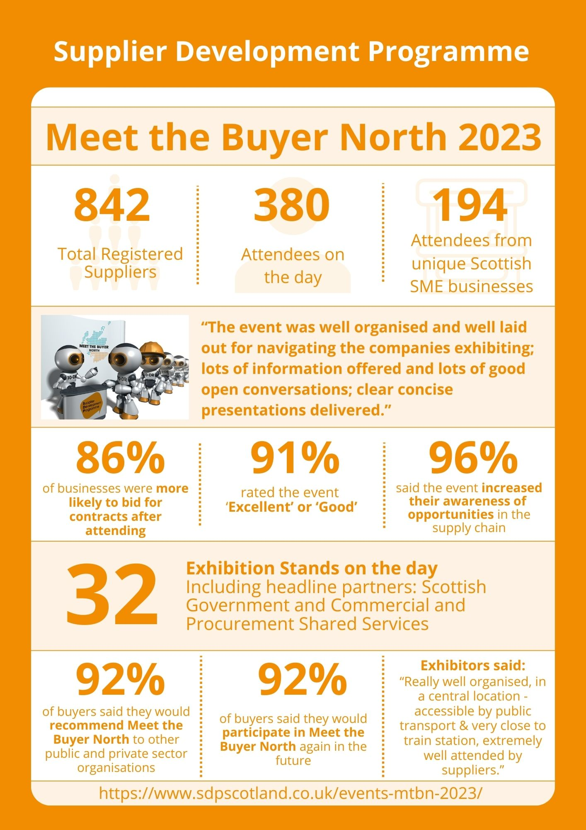

**Overview**

The Supplier Development Programme has published an online report on the Meet the

Buyer North 2023 event which took place on 12 September 2023 at The Music Hall, Aberdeen. Alongside the Supplier Development Programme, Scottish Government, and the Commercial and Procurement Shared Services (Aberdeen City, Aberdeenshire, and Highland Councils) were official partners of this event.

This free event affords suppliers in the North of Scotland unprecedented access to buyers and decision makers from across the Public and Private sector, with the opportunity to raise their profile as a business and prepare for upcoming contract opportunities.

**Supplier Registration and Attendance**

In total, 842 suppliers had pre-registered interest on the SDP website for Meet the Buyer North 2023. There were 380 actual attendees on the day. Of those, 242 attendees from 194 Scottish SME unique businesses attended Meet the Buyer North 2023.

**Buyer Exhibitions**

Exhibitors at Meet the Buyer North 2023 included headline partners: Scottish Government, the Commercial and Procurement Shared Services (Aberdeen City, Aberdeenshire, and Highland Councils), and the Supplier Development Programme.

In total there were 32 exhibition stands, which included a range of public sector buyers, business support organisations, and a number of supply chain contractors, including: Balfour Beatty, hub North Scotland, Ogilvie Construction, RJ McLeod, Robertson FM, Scottish Wholesale Association, and Vattenfall.

**Formal Agenda**

Fiona Conti, Chair of the Supplier Development Programme, and Councillor Christian Allard delivered a welcome address to open the main stage.

Richard Lochhead MSP, Minister for Small Business, Innovation, Tourism and Trade, was unable to attend on the day due to parliamentary business, but he provided a pre-recorded Ministerial Address.

Other presentations on the day include:

* 10:50am Aberdeen Shared Procurement Services: Doing business with Aberdeen City, Shire, and Highland
* 11:10am Scottish Government - Commitment to supporting Scottish SME and the Third Sector
* 11:30am Open discussion for SME and Third sector to ask the Panel questions on procurement
* 11:45am Hub North Scotland: Opportunities in Aberdeen and beyond
* 12:00pm How to Do Business with Balfour Beatty
* 1pm Aberdeen City Region Deal
* 1:20pm Local Outcome Improvement Plan - Aberdeen City
* 1:40pm Aberdeen Hydrogen Hub: Growing a Hydrogen Economy in the Aberdeen City Region
* 2pm Discover Your Perfect Match: Find Your Ideal Food & Drink Wholesaler
* 2:20pm Supplier Development Programme: Top Tips for Tendering
* 3pm Tendering with NHS Grampian

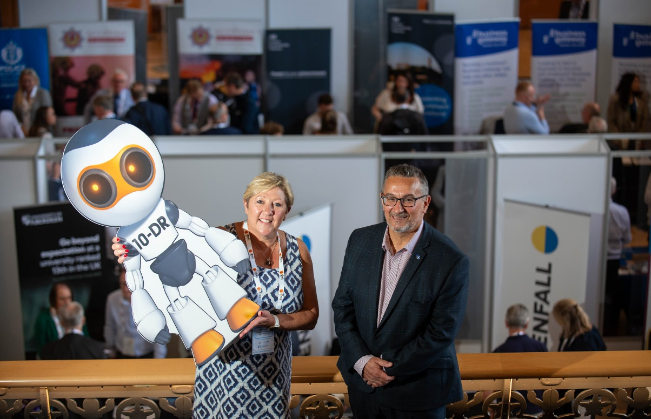

**Supplier Survey Feedback**

An online survey was distributed to all that attended Meet the Buyer North 2023. The survey was live from 12 September 2023 to 6 October 2023. 55 responses were received. 36 of these responses came from SMEs, Social Enterprises, and third sector organisations.

**The post-event survey highlighted that 86% of Scottish SMEs said they were more likely to bid for public contracts after participating in the event**.

**The survey also highlighted that:**

* 91% of suppliers rated the event as ‘excellent’ or ‘good’.
* 96% of respondents said that this event had increased their awareness of opportunities for their businesses in the supply chain.
* 84% of suppliers felt more confident about bidding for public sector contracts after attending Meet the Buyer North 2023.
* 86% of suppliers believe they made contacts at Meet the Buyer North 2023 that may have the potential to benefit their business in the next year, either through bidding for future contracts or being invited to Quick Quote.
* 91% feel Meet the Buyer North was important in helping SMEs, charities and third sector organisations learn more about upcoming contracts and understand the tendering process.

**When considering the Scottish Government’s commitment to becoming a Net Zero society by 2045:**

* 93% of respondents were aware of the Scottish Government’s commitment to achieving a Net Zero society.
* 66% of respondents said they have an existing policy to support a reduction in its carbon footprint.

**Some comments from suppliers included:**

* “The event was very informative, and the exhibitors were all very forthcoming with information and more importantly guidance on how best to engage with them.”
* “The event was well organised and well laid out for navigating the companies exhibiting; lots of information offered and lots of good open conversations; clear concise presentations delivered.”
* “A good day - lots of energy in the room and some very open and approachable buyers."
* “Well organised, good location & a worthwhile visit.”
* “It was a great event with a good turnout. It was good to meet with the real buyers and stakeholders within the organisations.”
* “Really enjoyed this year’s Meet the Buyer North Event. Great speakers, fantastic venue.”
* “It was an excellent event all round. A larger presentation space would have been good, seemed to be standing room only a lot of the time!”
* “Only one piece of negative feedback. I attended some of the seminars on the day and found it difficult to hear some the speakers. The doors could have been closed.”
* “It would be great if the buyer had the contacts available for estates or departments. As a manufacturer, those are the contacts we need before we get to tender stages.”

**Exhibitor Feedback Survey**

An online survey was distributed to all that exhibited at Meet the Buyer North 2023. 12 responses to this survey were received between 12 September 2023 and 6 October 2023.

**The post event survey highlighted:**

* 92% of buyers said they would participate in next year’s Meet the Buyer North.
* 92% of buyers said they would recommend Meet the Buyer North to other organisations.
* 83% of buyers felt Meet the Buyer North helped their supply chain be more open and transparent.
* 83% of buyers felt Meet the Buyer North 2023 made public contracts more accessible to SMEs.

**Some comments from buyers included:**

* “The event was well organised and well attended.”
* “Great chance to speak to SMEs, better understand the barriers they face when bidding for public sector contracts.”
* “Good venue; well organised event; worthwhile interactions.”
* “Really well organised, in a central location - accessible by public transport & very close to train station. The event was extremely well attended by suppliers.”
* “It was my first such event, but I found it to be well run and attended. I made a number of useful contacts and look forward to attending the next such event. Communications regarding refreshments for organisations running stalls could be improved.”
* “As with all the MTB events it was great to get out and speak to suppliers. The only thing that was a little disappointing was only having 2 lunches/coffee vouchers per stand despite being able to register more than 2 people to attend. At previous events, there was always a lunch provided for each person who registered to attend.”
* “The event was run smoothly, and it was of great benefit. The App however would not always connect with contacts or send through the invites. Also, if you registered slightly late then your details were not available to invite.”
* “I did not appreciate having to install an app on my personal mobile, which was ultimately not actually required. Organisers should also appreciate that exhibitors may not have access to emails on the day of event. There was information sent out which I wasn't aware of on the day as the communication had gone to the email address.”

**All feedback from suppliers and buyers is valuable and will be applied to future events organised by the Supplier Development Programme.**

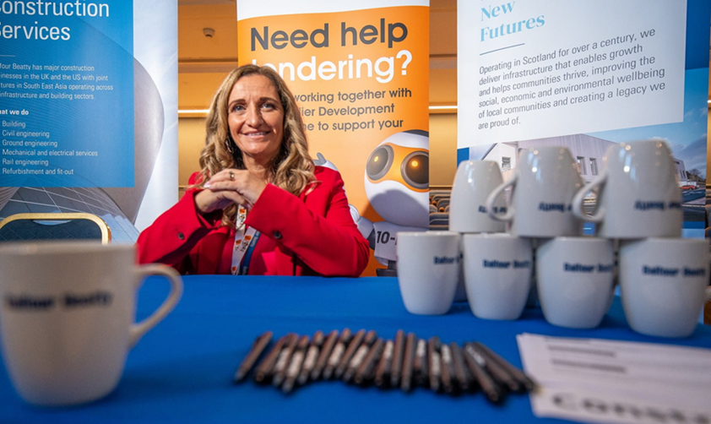

**Promotion through the Supplier Development Programme**

**Social Media Analytics**

Prior to the event, SDP published 195 posts, across Facebook, LinkedIn and Twitter, promoting Meet the Buyer North. The campaign ran from 21 July 2023 to 12 September 2023. Collectively, the posts earned 34,195 impressions (the number of times users saw a post) and 1,331 engagements (the number of times users interacted with posts). In total, there were 383 clicks on the links embedded in these posts.

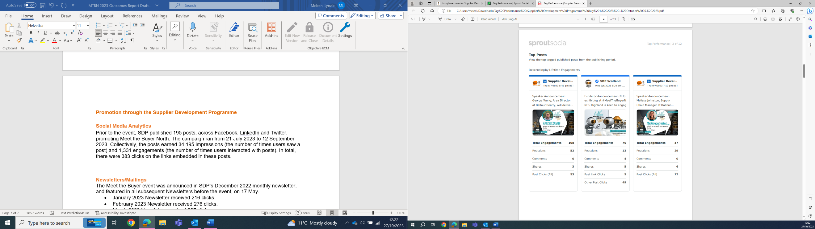**Highest performing posts include:**

**Newsletters/Mailings**

The Meet the Buyer North event was announced in SDP’s June 2023 monthly newsletter, and featured in all subsequent Newsletters before the event, on 12 September.

* June 2023 Newsletter received 56 clicks.
* July 2023 Newsletter received 277 clicks.
* August 2023 Newsletter received 413 clicks.
* September 2023 Newsletter received 272 clicks.

SDP also utilised a targeted approach to email marketing, sending out mailings to all suppliers based in the North of Scotland. The first mailing, a ‘one month to go’ reminder, received 155 clicks. A ‘one week to go’ reminder was also sent out, receiving 82 clicks.

**Meet the Buyer North 2023 Collateral**

The presentation sessions from Meet the Buyer North 2023 are available on the [SDP [YouTube](https://www.youtube.com/channel/UCIqFOcumpnKlu1wQOrIkQvQ) channel](https://www.youtube.com/channel/UCIqFOcumpnKlu1wQOrIkQvQ), allowing those who could not attend on the day access to watch the full range of speaker presentations and the tendering workshop delivered by the Supplier Development Programme.

**Post Event**

Both delegate and exhibitor feedback has been reviewed and individual questions addressed. SDP has had discussions with its event contractor, addressing the issues raised with regard to queues and other points so that we continue to provide a high-quality service to both the public and private sectors.

**Contact**

More information on the Supplier Development Programme can be found at [www.sdpscotland.co.uk](http://www.sdpscotland.co.uk) and on social media via [Twitter](https://twitter.com/sdpscotland), [Facebook](https://www.facebook.com/SupplierDevelopmentProgrammeScotland), [LinkedIn](https://www.linkedin.com/company/sdpscotland/), and [YouTube](https://www.youtube.com/channel/UCIqFOcumpnKlu1wQOrIkQvQ).