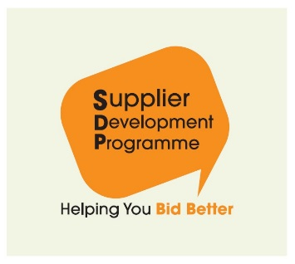
SDP News Release

Monday, 6 January 2020

For immediate release

Wheatley Group Joins Supplier Development Programme

The Supplier Development Programme (SDP) has welcomed Wheatley Group as its first Housing Association member.

Wheatley Group will now be able to utilise the Supplier Development Programme to alert the market of upcoming contract and framework opportunities to more than 14,500 registered micro, small, medium and supported businesses.

To put this new partnership’s best foot forward in 2020, Wheatley Group, the Dumfries and Galloway Housing Partnership (DGHP), which recently joined Wheatley, and the Supplier Development Programme have organised a regional Meet the Buyer event in Dumfries on 20 January 2020.

The event is aimed at small and medium sized businesses in Dumfries and Galloway, Scottish Borders, South Ayrshire and other local authority areas that want to be involved in future public sector contracts with DGHP.

SMEs will learn about upcoming opportunities and take part in workshop sessions delivered by the Supplier Development Programme, including topics such as top tips for tendering and working with the public sector.

Gillian Cameron, Supplier Development Programme Manager, said:

“We are aware that typically small businesses want to do work with housing associations, and we are delighted to welcome Wheatley Group as our first housing association member.

“Our future work with Wheatley Group promises to be a dynamic partnership that will create a more joined up approach, linking to potential framework opportunities, including those through one of our other new members, the Scottish Procurement Alliance, as well as the wider public sector.”

Ends

Notes for Editors

- SDP is a publicly-funded partnership led by Local Authorities, working in conjunction with Scottish Government and other public bodies, to bring Scottish SMEs support in all aspects of tendering. By assisting businesses to become tender ready for public procurement, SDP improves all-round efficiency, sustainability and market potential.

- For more information on Wheatley Group, visit www.wheatley-group.com.

- In Scotland, there is an annual public spend of £11billion. In the UK, there is an annual public spend of £240billion. SDP Scotland offers free training throughout Scotland to Scottish SMEs to support and champion them tendering for this work.

- Membership of SDP provides:
  - early market awareness and promotion of potential tender/supply chain opportunities;
  - support at the organisation’s tender-related supplier engagement events;
  - additional participation in the organisation’s tender and supply chain opportunities; and
  - assistance to organisations to promote the availability of the Supplier Development Programme’s free procurement training to the organisation’s supply base.

- Visit www.sdpscotland.co.uk for more information.

For media enquiries, contact:

Jennifer Payne
Development Officer – Marketing and Events
SDP Scotland
t: 01698454889
m: 07584174531
e: jennifer.payne@southlanarkshire.gov.uk

